Homework 4

|  |  |
| --- | --- |
| **Meta information** | |
| Name | Savan Kiran |
| Program | Masters in Computer Science |
| Questions skipped | N/A |
| Questions substituted | N/A |
| Extra credit questions | N/A |

# PART A

We can identify the Clicking coordinate system using the data cursor tool from MATLAB. The resulting image is displayed below.

(0,0)

X axis

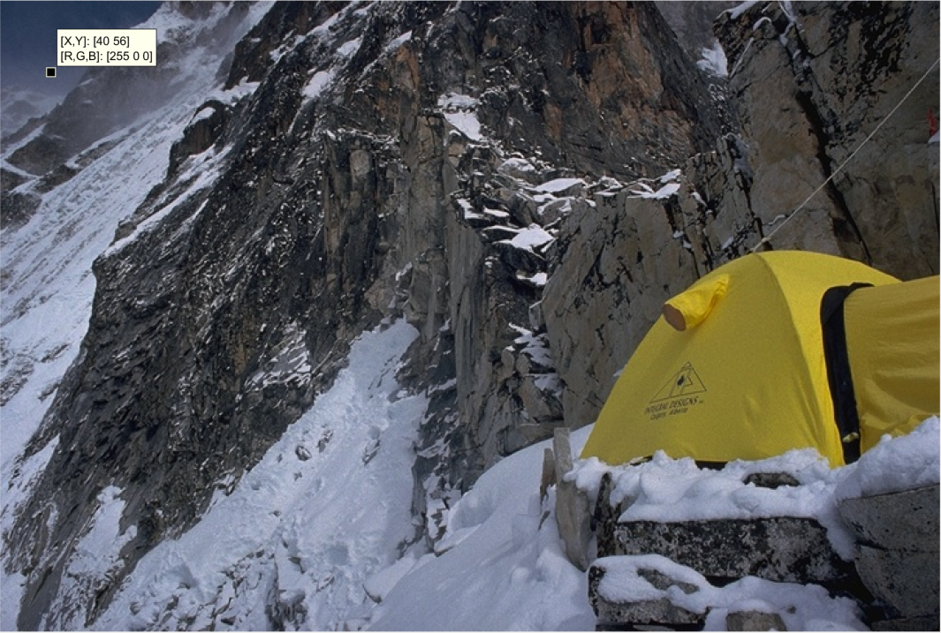

Y axis

Figure 1. Clicking coordinates. Origin is in the top-left corner, X-axis points right and Y-axis points down.

The origin for the Clicking coordinate system is at the top left corner. X-axis runs in the right direction whereas Y-axis runs downwards. There is a sample point indicated in Figure 1 corresponding to (40, 56) highlighted using the Matlab’s data cursor tool which also confirms the properties of the Clicking coordinate system.

Array Indices are not the same as Clicking coordinates. In fact, they’re reverse. The relationship can be expressed as follows,

$$If point P=\left(x, y\right) in Clicking coordinates \\ then, to access the point in Array indices, we do \\ imdata(y,x)$$

Let’s look at it more closely with an example where we try to set the color at location (40, 56) in Clicking coordinates (from previous example) to Red. Below is a code snippet to do the same,



Figure 2 shows the result of the above code snippet.

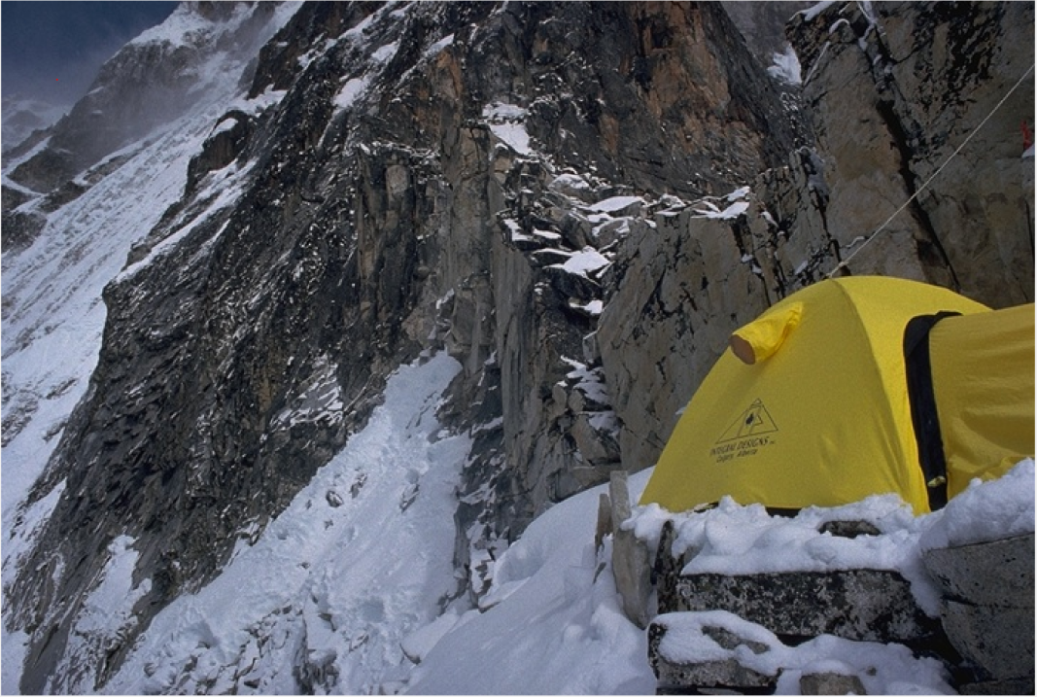

Figure 2. A point in Clicking coordinates is colored red using Array index access. (The red pixel is inside the red circle)

# PART B

In the given image, we note that the X-axis goes left from center, Y-axis goes right from center and Z-axis goes up from center and that the grid lines are 1 inch apart. Using these information, we calculate the world coordinates for 15 points. Table 1 shows the list of points.

Now, we use the Matlab’s data cursor tool to identify the image coordinates for these 15 points in Standard Image Coordinate System. The values are shown in Table 2.



Table 1. 15 points in world coordinates



Table 2. Coordinates of 15 points in Standard Image Coordinate System

Using the points information, we calculate the Camera Matrix, M and try to replot the 15 points in Standard Image Coordinates.

We first calculate the matrix, P which has 2 rows added for each point given by, $P_{i}$

$$row1=\left(P_{i}^{'}, 0000, {-u}_{i}P_{i}^{'} \right) \\ row2=\left(P_{i}^{'}, 0000, {-v}_{i}P_{i}^{'} \right)$$

From P, we calculate the Camera Matrix, M as follows,



Once we have the components of Camera Matrix, M, we can calculate the projected points as follows,

$$u_{i}=\frac{m_{1}.P_{i}}{m_{3}.P_{i}} \\ v_{i}=\frac{m_{2}.P_{i}}{m_{3}.P_{i}}$$

We now plot the projected points (shown in blue) alongside the actual image points (shown in red) in the Standard Image Coordinate System which is depicted in Figure 3.

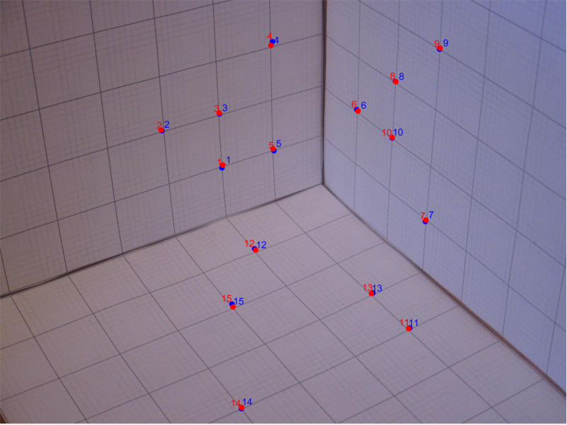

Figure 3. Blue shows projected points and red shows actual image coordinate points plotted in Standard Image Coordinate System

The RMS error for this Camera Matrix, M is calculated to be 4.2811.

# PART C

We now consider 2 pre-defined Camera Matrices and check how well can they project the 15 points from real world coordinates to the Standard Image Coordinates as against the points calculated in image coordinates earlier. The actual image coordinate points are shown in red, Camera Model 1 projected points are shown in blue and Camera Model 2 projected points are shown in green in Figure 4.

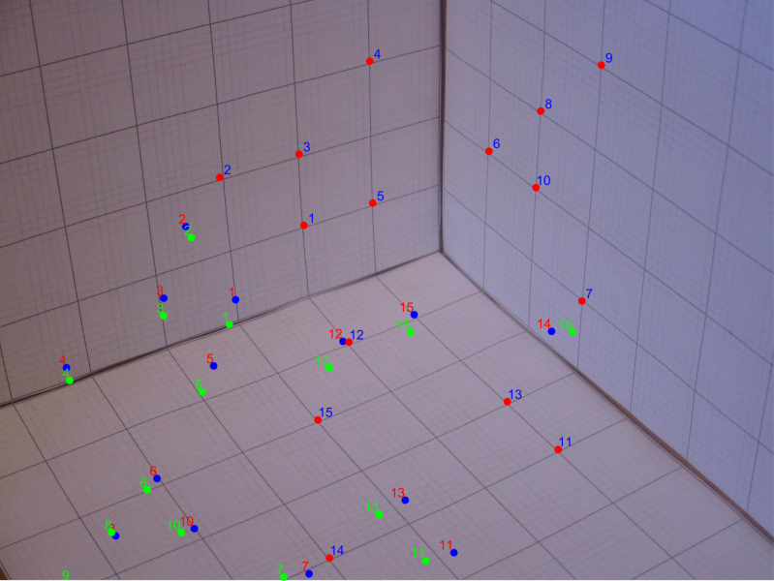

Figure 4. Red -> Actual image coordinate points, Blue -> Model 1 projected points and Green -> Model 2 projected points

Visually, we can see that the points projected by Model 1 (shown in blue) are closer to the actual points (shown in red) compared to the Model 2 projected points (shown in green). We can verify this by calculating the RMS error which is shown below.



Hence, for the given set of 15 points, Camera Model 1 is more accurate. However, we can’t say the same for all points.

# PART D

The Standard XY coordinate system and the image coordinate system are shown in Figure 5.

(1,0)

(0,800)

(800,800)

(0,0)

(0,-1)

(-1,0)

(800,0)

(0,1)

(0,0)

Figure 5. Blue box and grid lines show XY coordinates and orange box and grid lines show image coordinates.

To convert points from XY coordinates to image coordinates, we do a sequence of transformations that includes translation, flip, rotate and scale. Below are the matrices corresponding to each of the transformation. We can view the transformations in a straightforward way if we look at them as modification to origin and grid lines to get the image coordinate system.

1. Translate x by -1 and y by 1.
$$M_{T}=\begin{matrix}1 & 0 & -1 \\ 0 & 1 & 1 \\ 0 & 0 & 1\end{matrix}$$

2. Flip on X-axis
$$M_{F}=\begin{matrix}1 & 0 & 0 \\ 0 & -1 & 0 \\ 0 & 0 & 1\end{matrix}$$

3. Rotation by 180 degrees
$$M_{R}=\begin{matrix}-1 & 0 & 0 \\ 0 & -1 & 0 \\ 0 & 0 & 1\end{matrix}$$

4. Scale by 400 pixels

$$M_{S}=\begin{matrix}400 & 0 & 0 \\ 0 & 400 & 0 \\ 0 & 0 & 1\end{matrix}$$

The final transformation given by the product of all the transformation is,

$$M=M_{T}M_{F}M_{R}M_{S}$$

The Matrix is given by,

$$M= \begin{matrix}-400 & 0 & -1 \\ 0 & 400 & 1 \\ 0 & 0 & 1\end{matrix}$$

1. Mapping for (-0.5, -0.5) in XY coordinate space = (200,600) in image coordinate space
2. Mapping for (-0.5, 0.5) in XY coordinate space = (200,200) in image coordinate space
3. Mapping for (0, 1) in XY coordinate space = (400,0) in image coordinate space